# CS 255 System Design Document

Kody M. Greenberg  
CS 255 System Design Document  
4/10/2023

## UML Diagrams

## UML Use Case Diagram

### UML Activity Diagrams

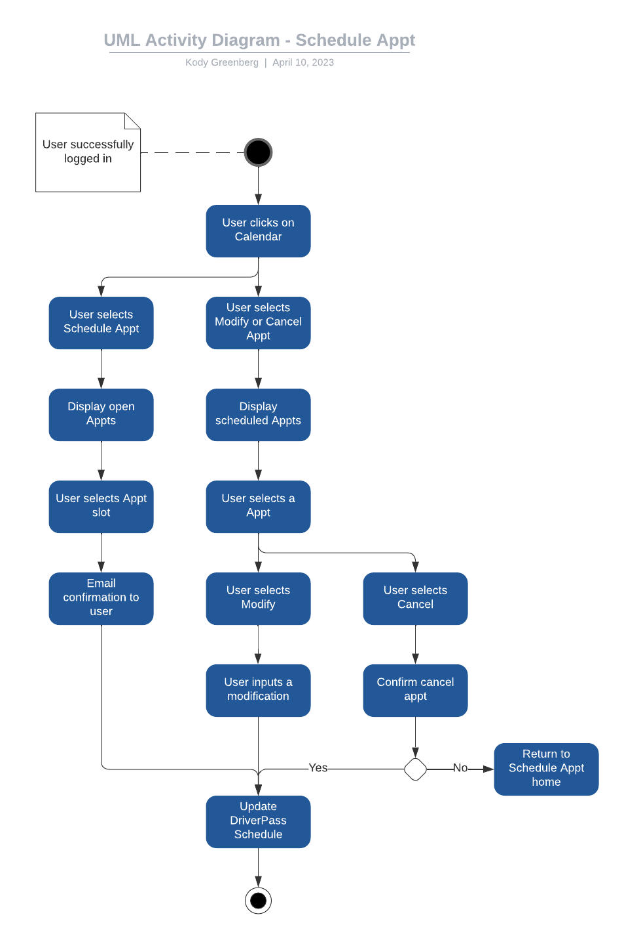

### UML Sequence Diagram

### UML Class Diagram

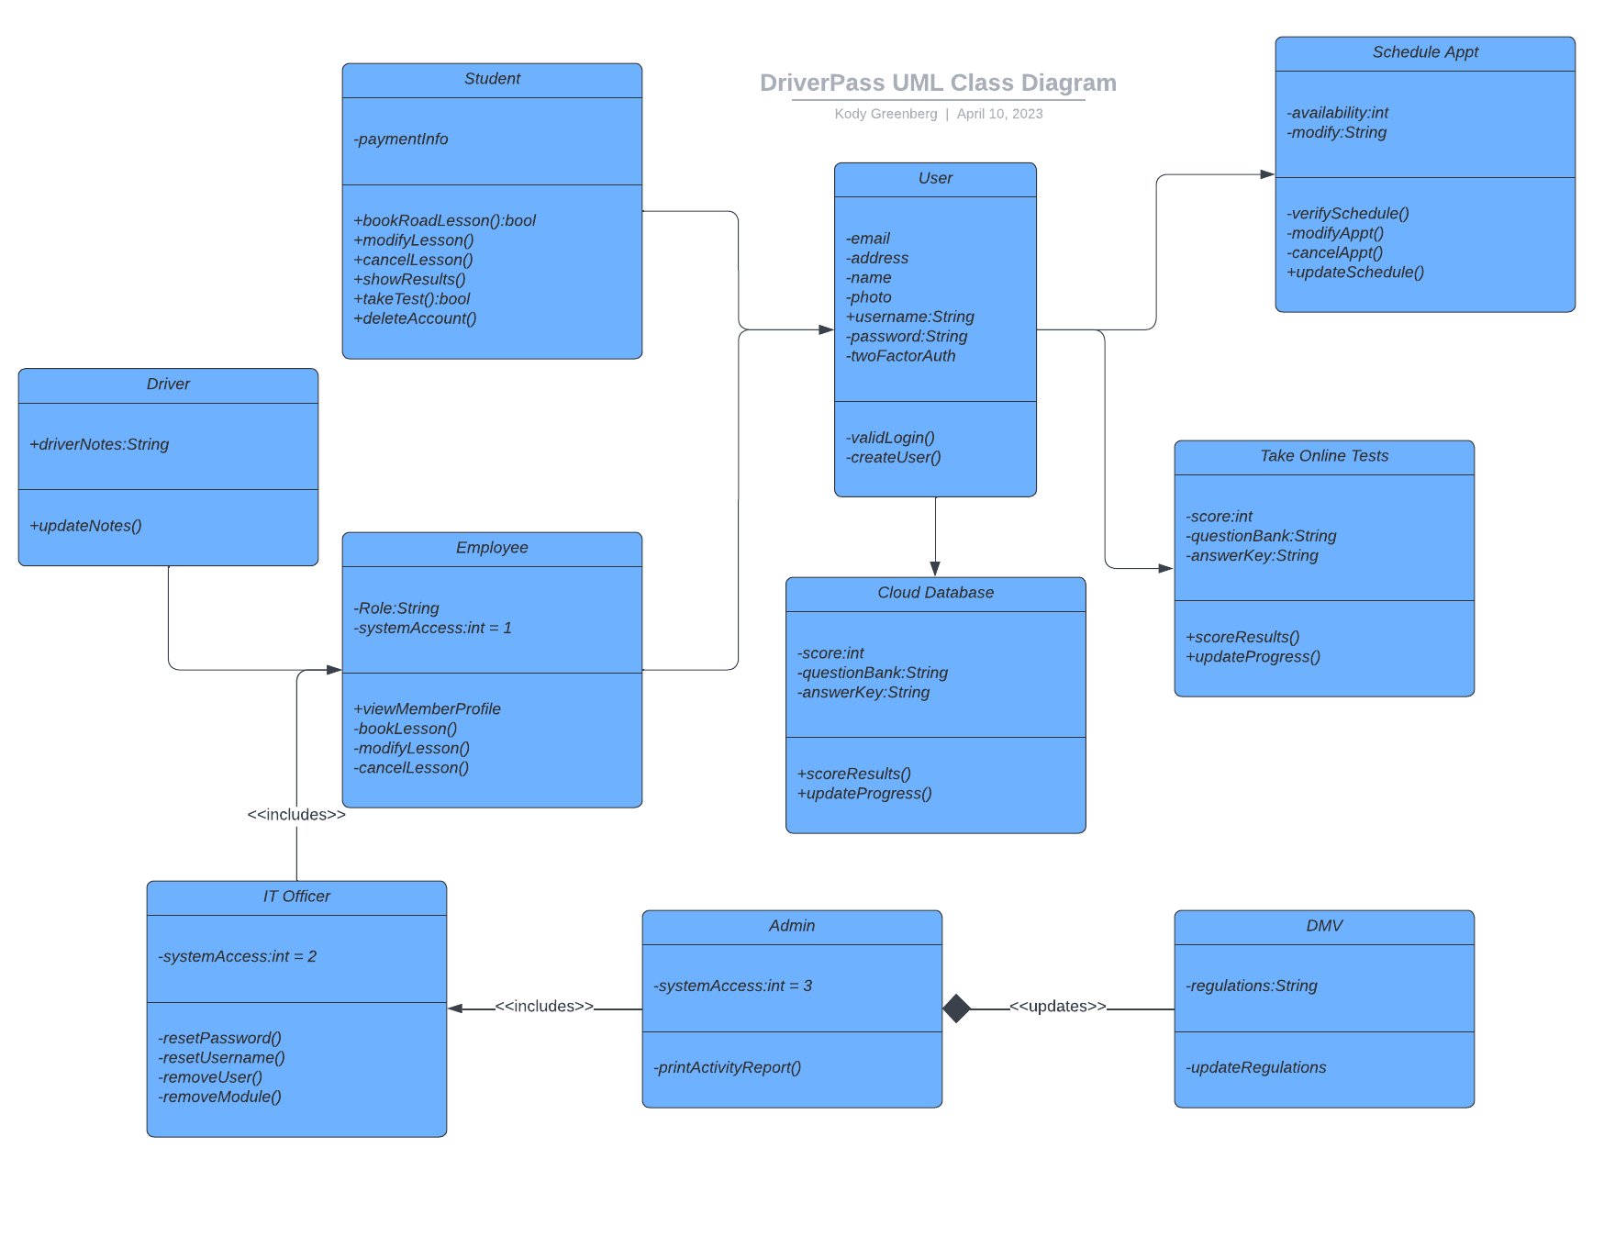

## Technical Requirements

* *Cloud Database integration*
* *Scheduling Software (calendar and booking appointment capabilities)*
* *Two Factor Authentication security*
* *Encrypted user information*
* *Internet access*
* *Data integration from DMV*
* *Three computers for the office*
* *Excel report creation*
* *Role based access rights*
* *History of changes made*